ASP.NET Core Web API – Employee Hands-On
Implementation and Testing using Visual Studio Code and Swagger

1. Objective
Create an ASP.NET Core Employee Web API, define Employee, Department and Skill models, implement controller endpoints, configure Swagger, build the project and test the API.

2. Project Creation
cd C:\Users\hp
dotnet new webapi -n EmployeeWebApi --use-controllers
cd EmployeeWebApi
code .

3. Model Classes

Employee.cs
namespace EmployeeWebApi.Models
{
public class Employee
{
public int Id { get; set; }
public string Name { get; set; } = string.Empty;
public int Salary { get; set; }
public bool Permanent { get; set; }
public Department? Department { get; set; }
public List<Skill> Skills { get; set; } = new();
public DateTime DateOfBirth { get; set; }
}
}

Department.cs
namespace EmployeeWebApi.Models
{
public class Department
{
public int Id { get; set; }
public string Name { get; set; } = string.Empty;
}
}

Skill.cs
namespace EmployeeWebApi.Models
{
public class Skill
{
public int Id { get; set; }
public string Name { get; set; } = string.Empty;
}
}

4. EmployeeController.cs
using EmployeeWebApi.Models;
using Microsoft.AspNetCore.Mvc;
namespace EmployeeWebApi.Controllers
{
[ApiController]
[Route("api/[controller]")]
public class EmployeeController : ControllerBase
{
[HttpGet]
public ActionResult<IEnumerable<Employee>> Get()
{
return Ok(new List<Employee>());
}
[HttpPost]
public ActionResult<Employee> Post(Employee employee)
{
return Ok(employee);
}
[HttpGet("standard")]
public ActionResult<Employee> GetStandard()
{
var employee = new Employee
{
Id = 1,
Name = "John",
Salary = 50000,
Permanent = true,
Department = new Department { Id = 1, Name = "IT" },
Skills = new List<Skill>
{
new Skill { Id = 1, Name = "C#" }
},
DateOfBirth = new DateTime(2000, 1, 1)
};
return Ok(employee);
}
[HttpPut("{id}")]
public ActionResult<Employee> Put(int id, Employee employee)
{
employee.Id = id;
return Ok(employee);
}
}
}

5. Program.cs – Swagger Configuration
var builder = WebApplication.CreateBuilder(args);
builder.Services.AddControllers();
builder.Services.AddEndpointsApiExplorer();
builder.Services.AddSwaggerGen();
var app = builder.Build();
if (app.Environment.IsDevelopment())
{
app.UseSwagger();
app.UseSwaggerUI();
}
app.UseHttpsRedirection();
app.UseAuthorization();
app.MapControllers();
app.Run();

6. Build and Run
dotnet add package Swashbuckle.AspNetCore
dotnet build
dotnet run
The project built successfully and ran on localhost. Swagger UI was used to inspect and test the Employee endpoints.

7. Output Screenshots
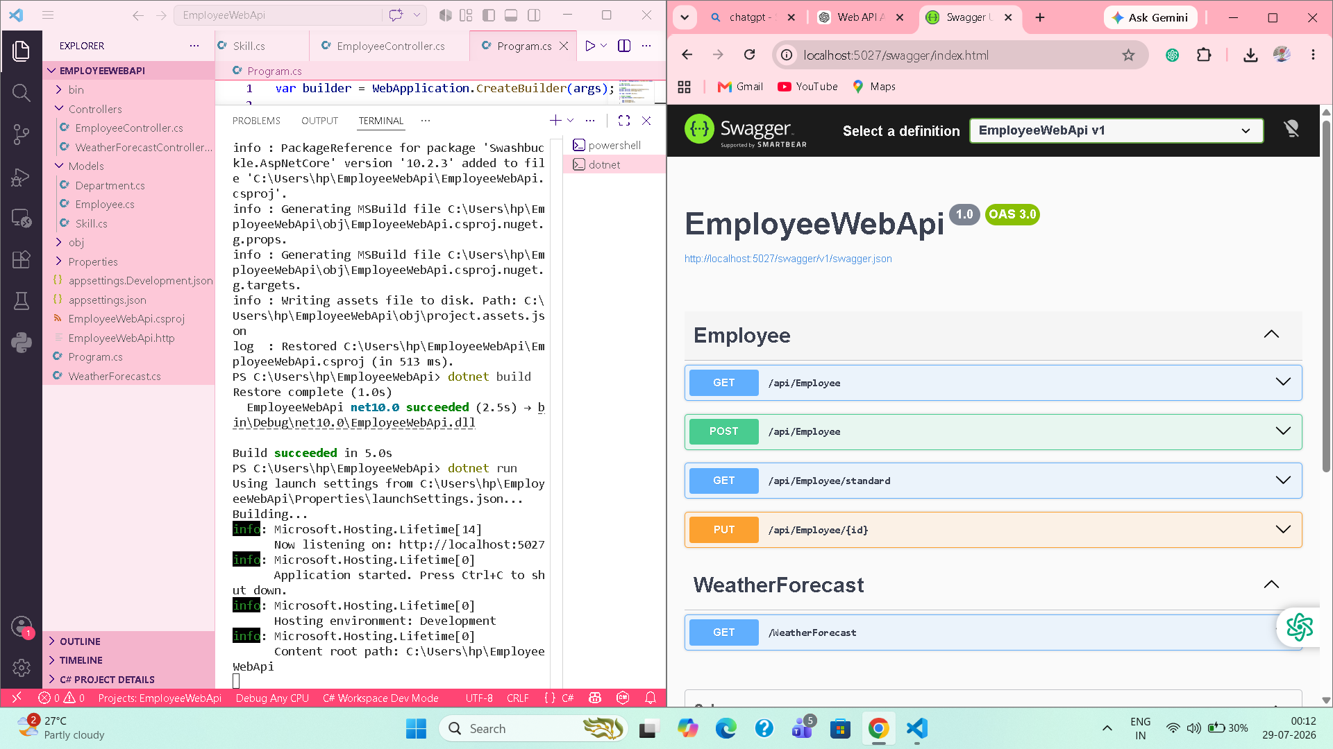
Figure 1: EmployeeWebApi running in VS Code with Swagger UI.
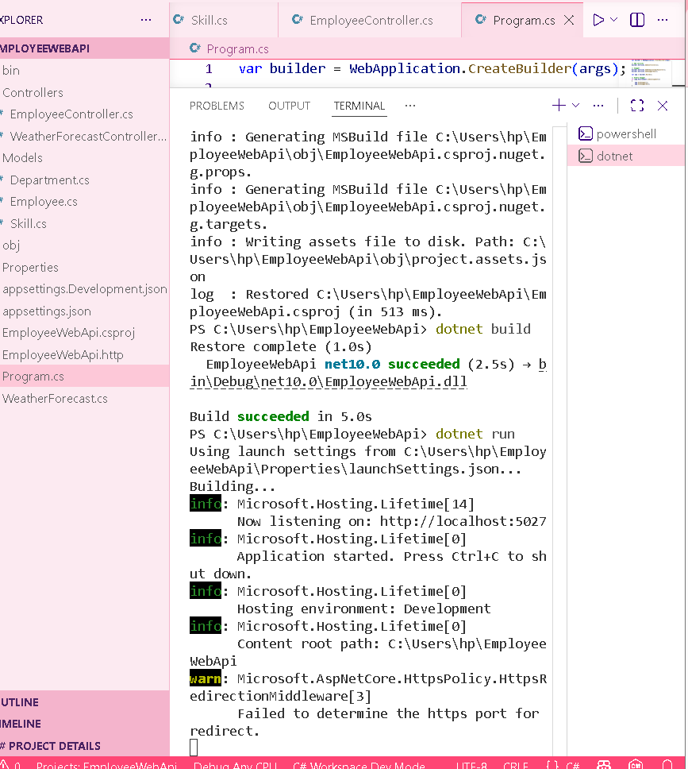
Figure 2: Successful build and application startup in the VS Code terminal.

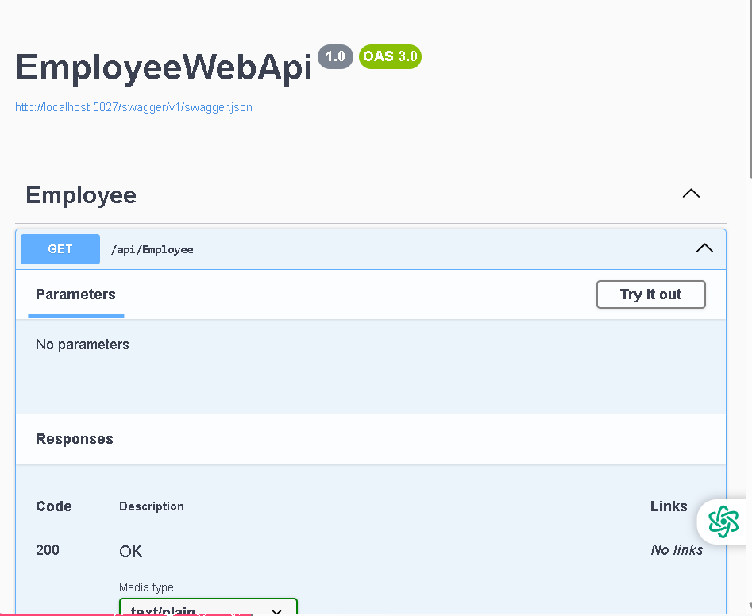
Figure 3: GET /api/Employee endpoint.
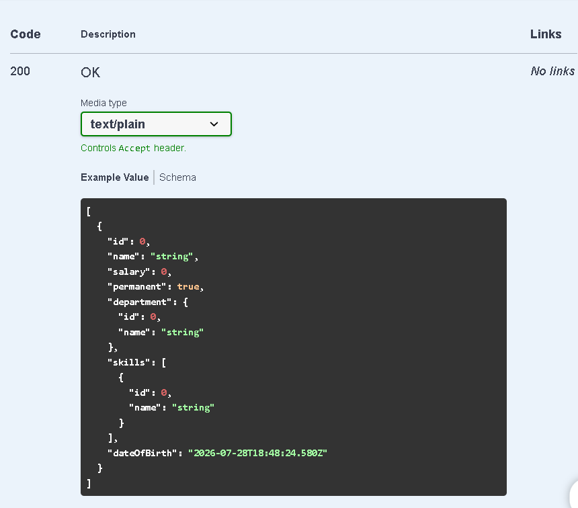
Figure 4: GET /api/Employee response schema/example.

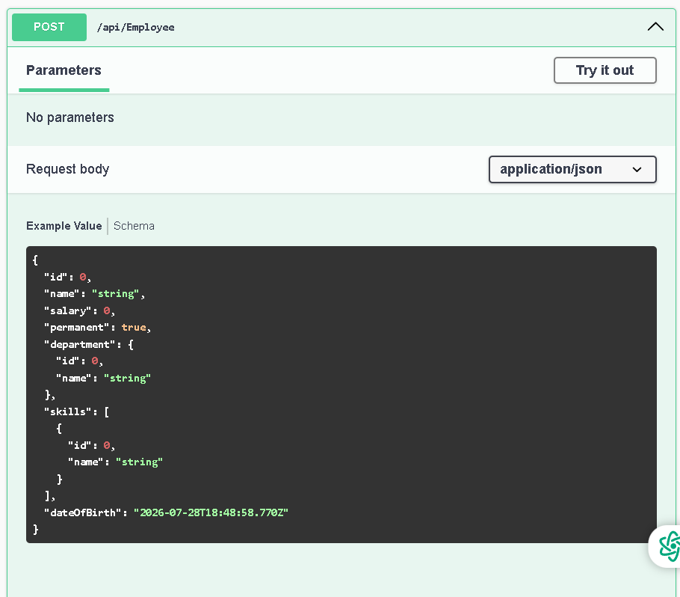
Figure 5: POST /api/Employee request body.
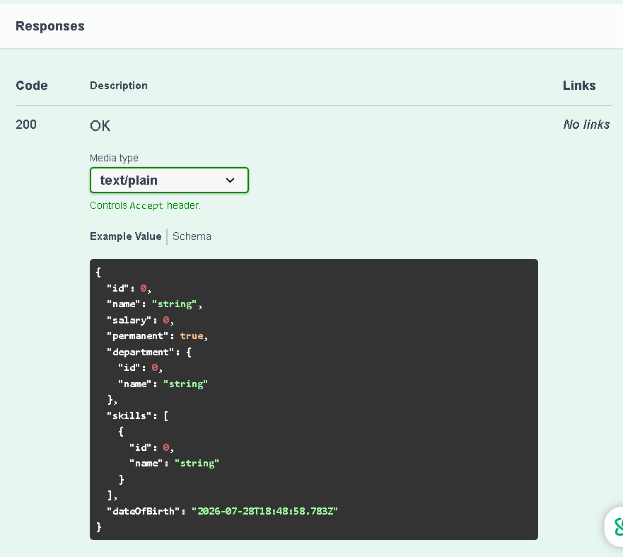
Figure 6: POST /api/Employee response schema/example.

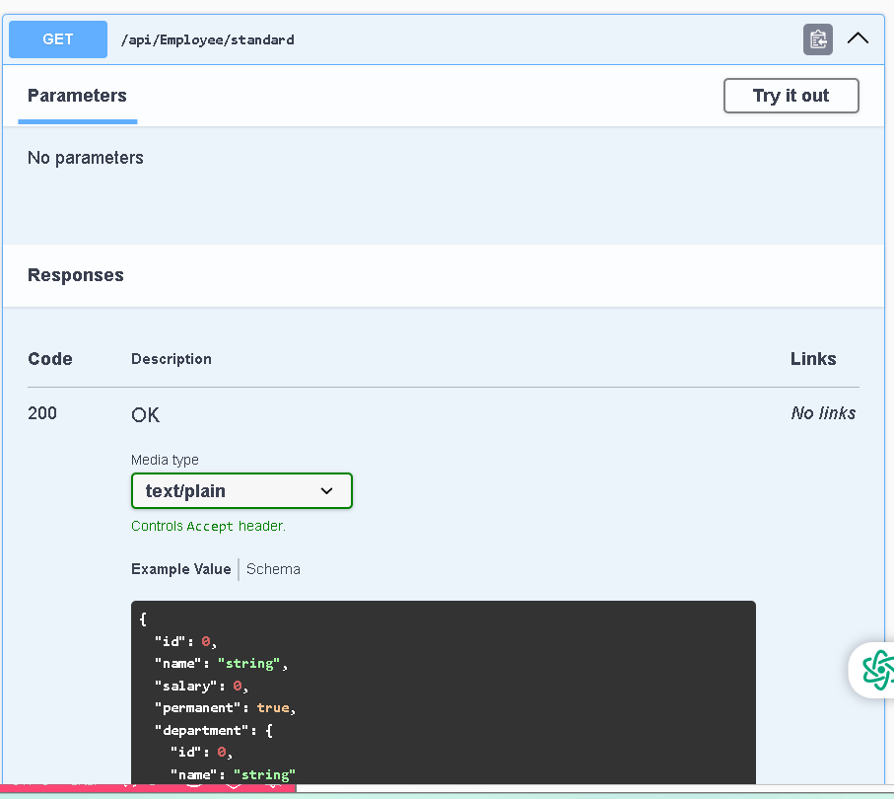
Figure 7: GET /api/Employee/standard endpoint.
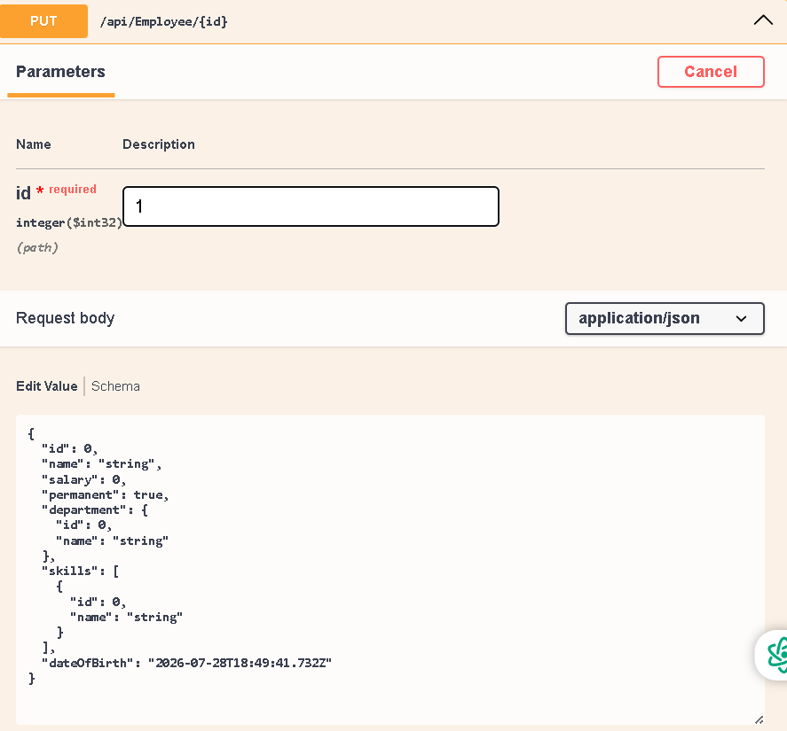
Figure 8: PUT /api/Employee/{id} request body and ID parameter.

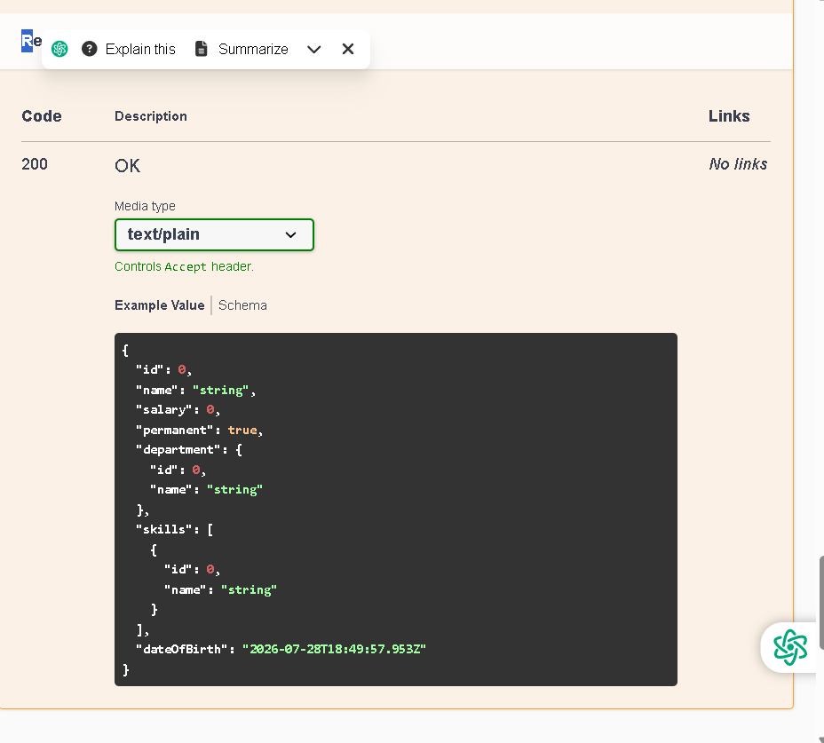
Figure 9: PUT /api/Employee/{id} response schema/example.

8. Result
The EmployeeWebApi was successfully created, compiled and executed. Swagger exposed the GET, POST, GET /standard and PUT /{id} Employee endpoints, and the HTTP 200 OK response definitions were displayed successfully.

9. Conclusion
The hands-on demonstrates ASP.NET Core Web API development using model classes, controllers and Swagger/OpenAPI documentation and testing.

